NgRX - Reactive Extensions for Angular.It is collection of reactive extensions like Ngrx/store,apex, devtools,router,db

@ngrx/Store, for ex if there are 2 sibling components and they have to communicate data with each other , we use observables, service or emit to parent and forward to child component

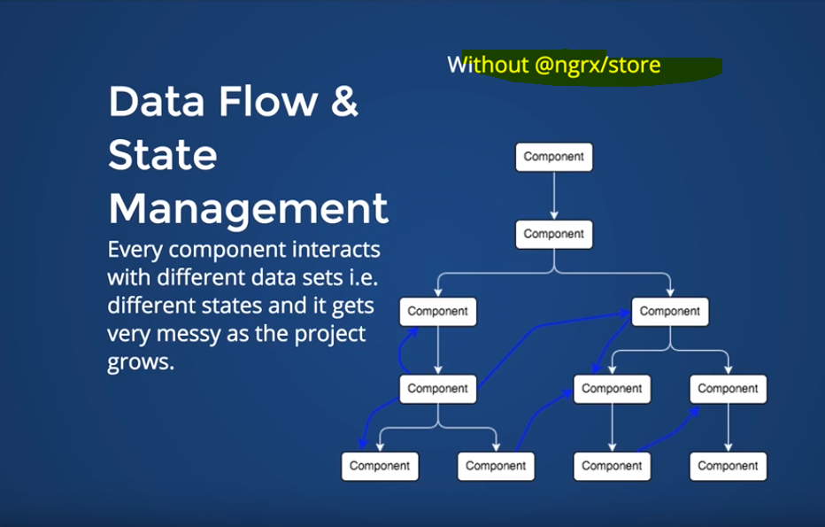

Chat app - 1. Write message component , heading comes under child component

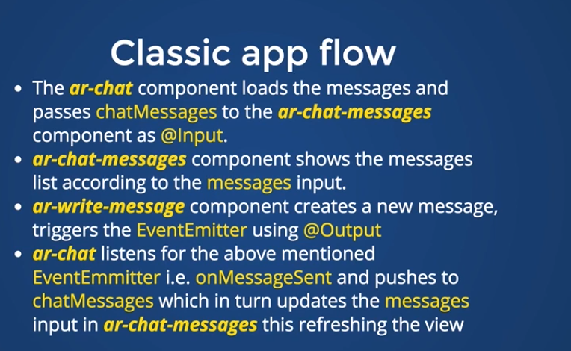

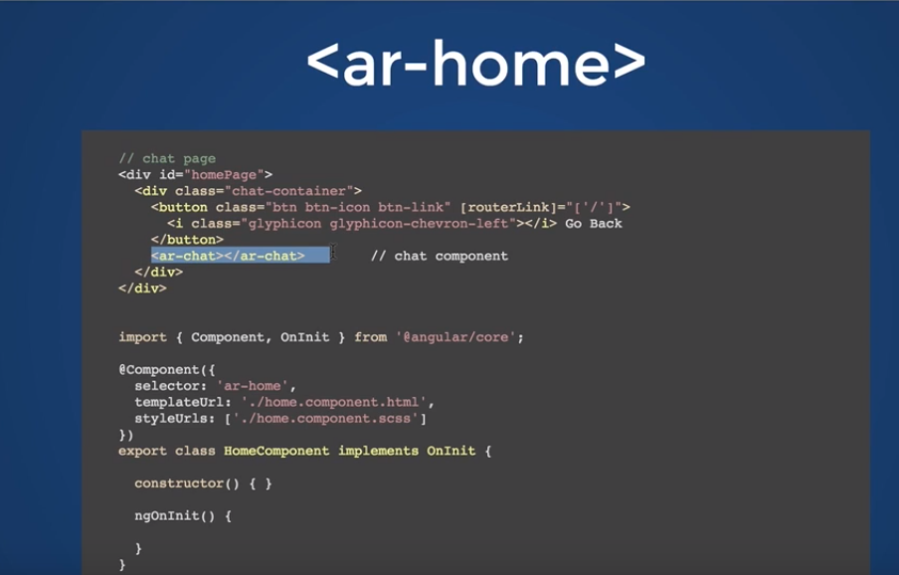

We have 2 components in (ar-chat) , chat messages and write messages

We are passing messages array with model chat messages inside , so from parent component (ar chat) we pass data into ar- chat messages and we listen for event (onMessagesent) for **write** component, so when we enter a new message it emits an event to the parent which updates the array chat messages, so chat component renders it

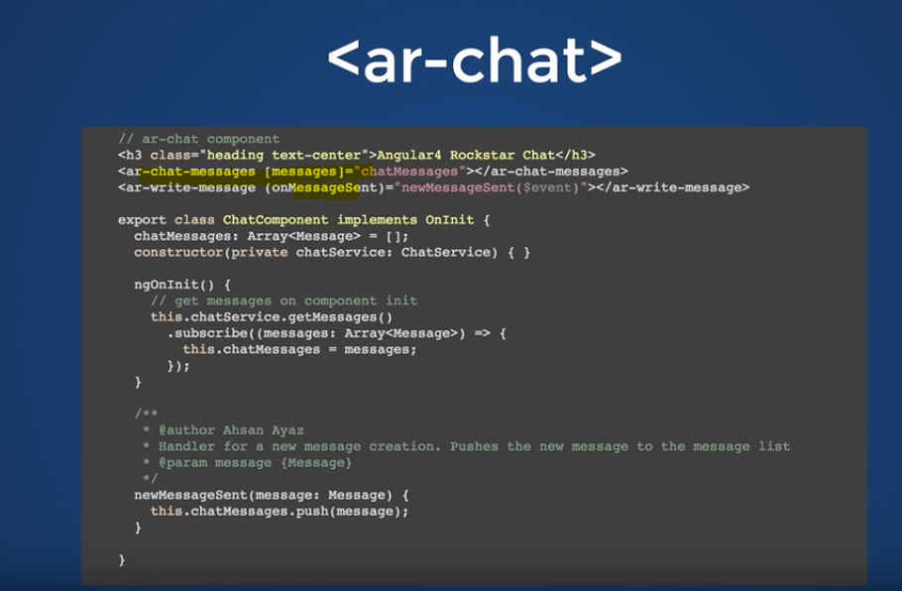

Chat messages loops through message component, remove message method removes the message when we hover through it

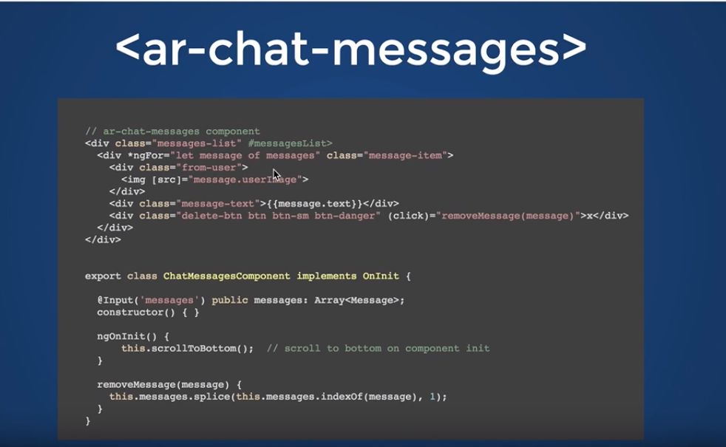

Remove message method

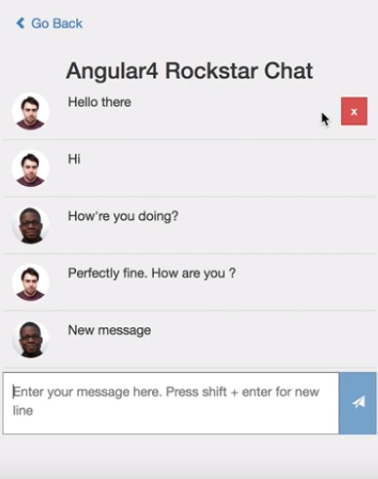

**SEND MESSAGE METHOD** - it creates a new message and then emits it

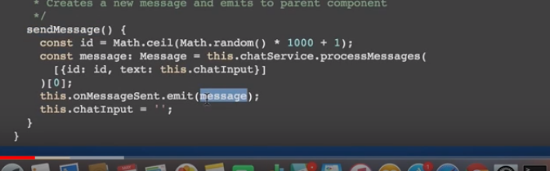

The complex app flow simplified BY NGRX/STORE

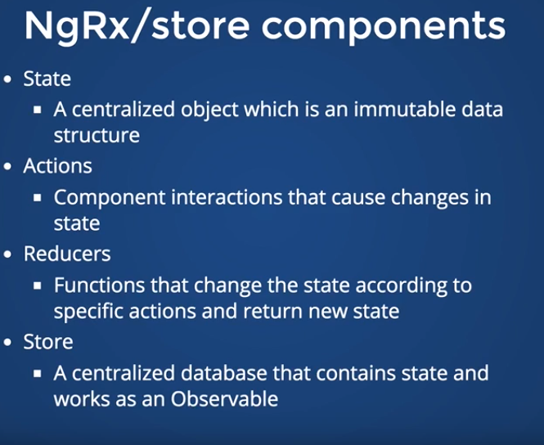

ngrx/store - when a component performs an action, the store updates every other component which relates to it

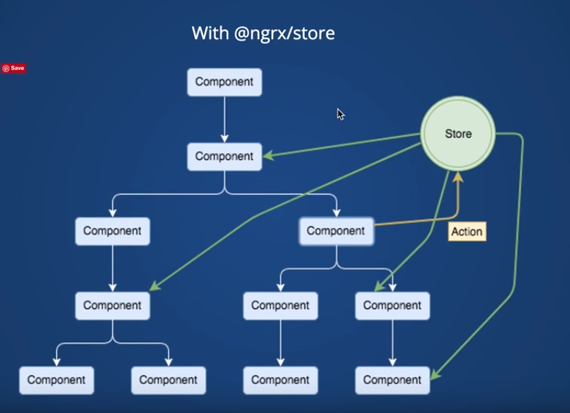

**Working with store**

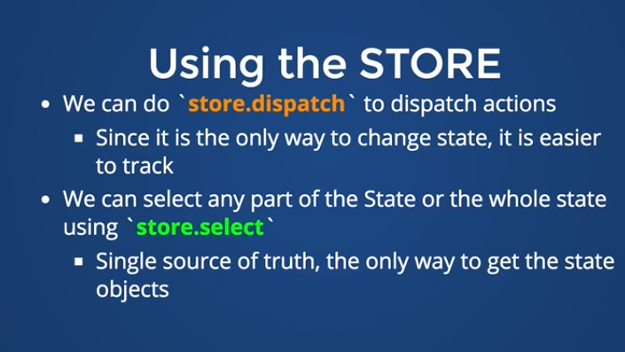

We have a filter which uses ngrx/reducer which shows my or all messages

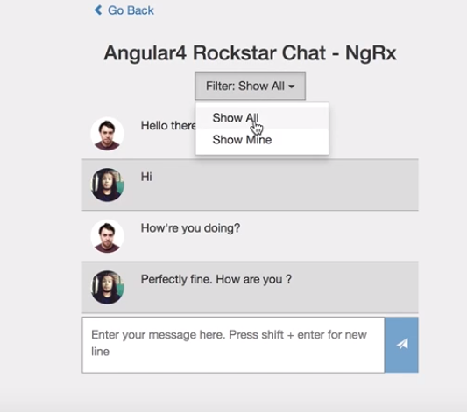

Coding with ngrx/store

We dont pass any model inside child component and we not listening to any event from child component as well

When component is initiated using ngOninit we trigger loadmessages() method which gets message from service

We are looping over messages model via direct observable |async , if anything changes in store we rerender the view

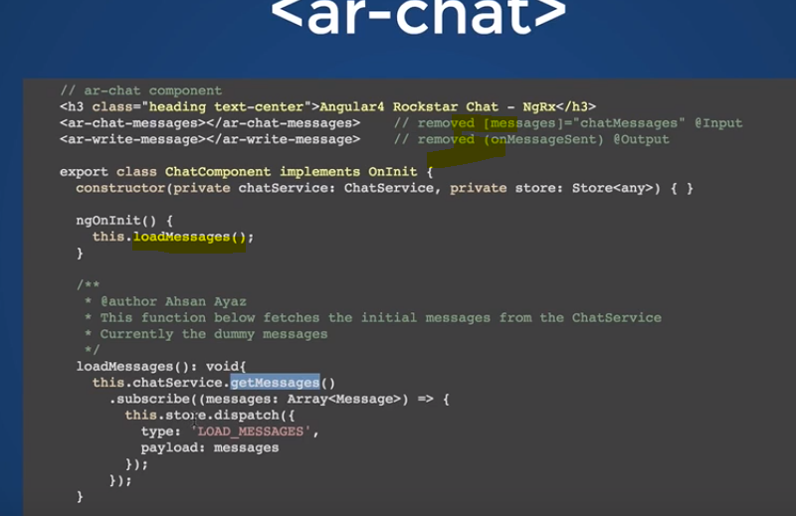

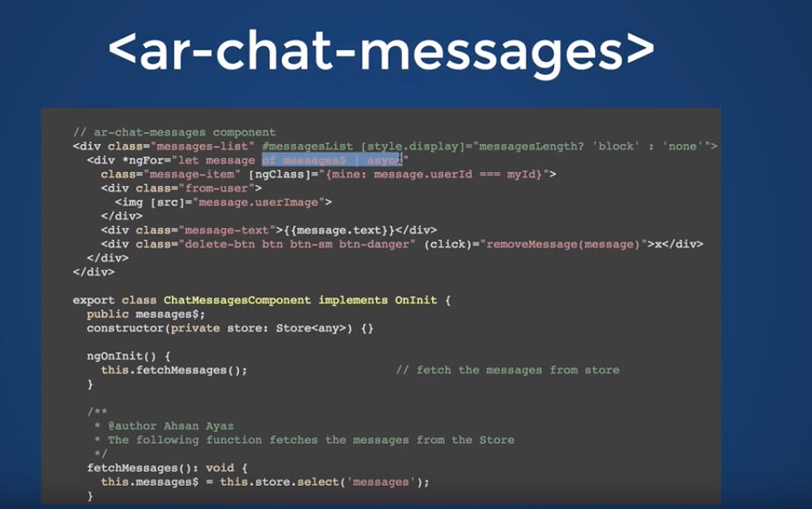

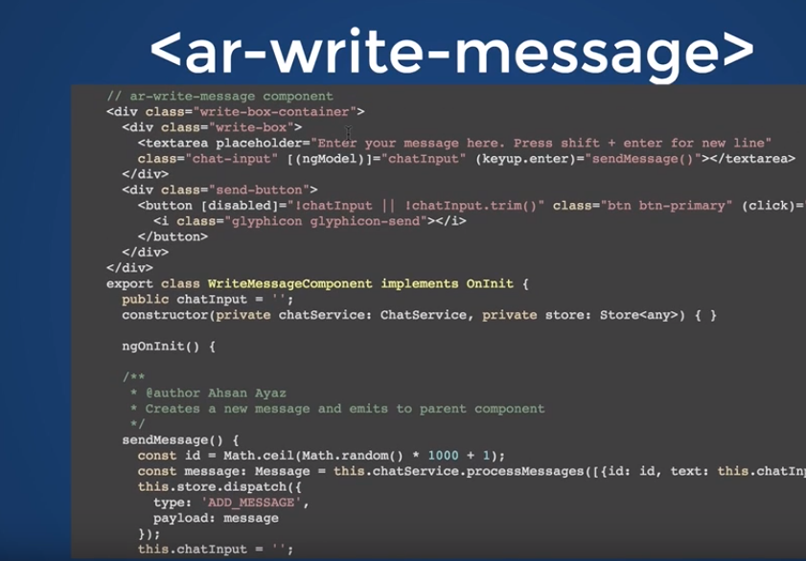

Reducer returns a new state,we dont push in previous state beacuse state is immutable

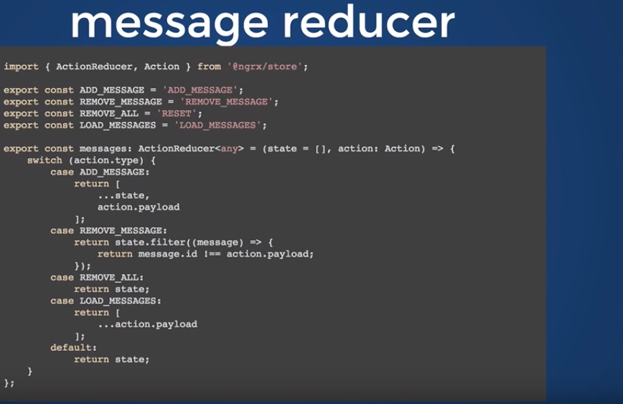

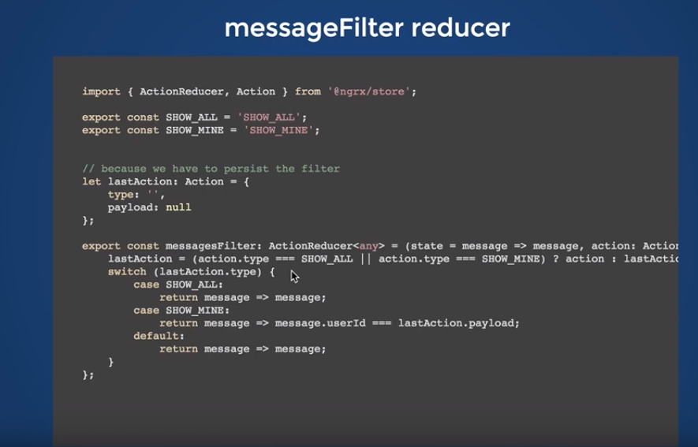

Joining reducers - one is getting messages, other is filtering

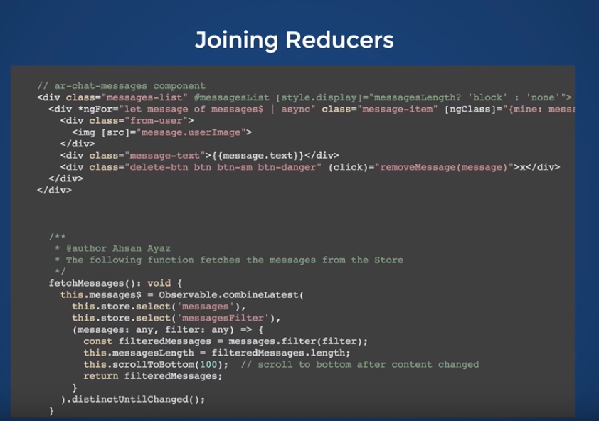

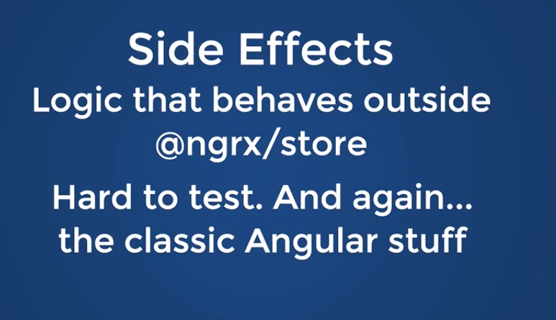

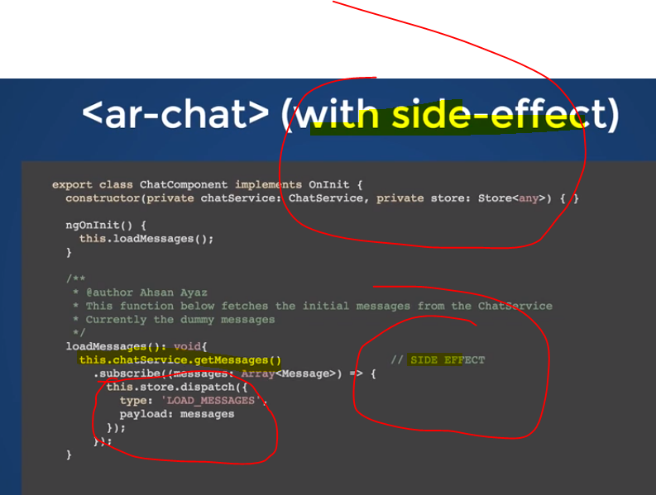

We have @effect by which we can tell store that we will dispatch an action, in which we have load message action in which

We have get messages function, if success we emit load_message success action, else load action failure

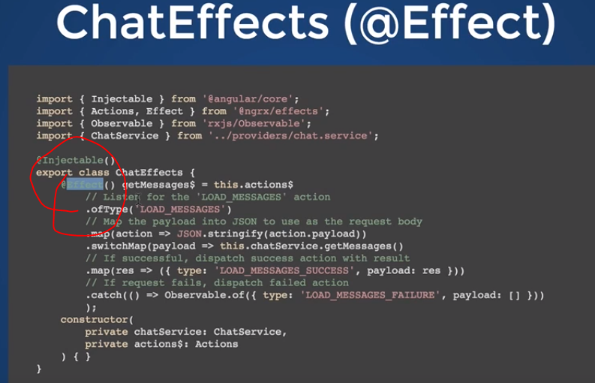

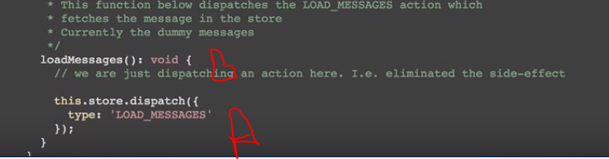



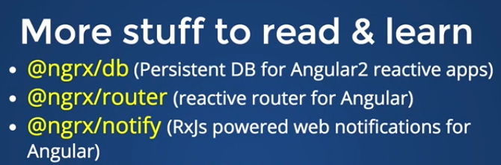

Ngrx-devtools

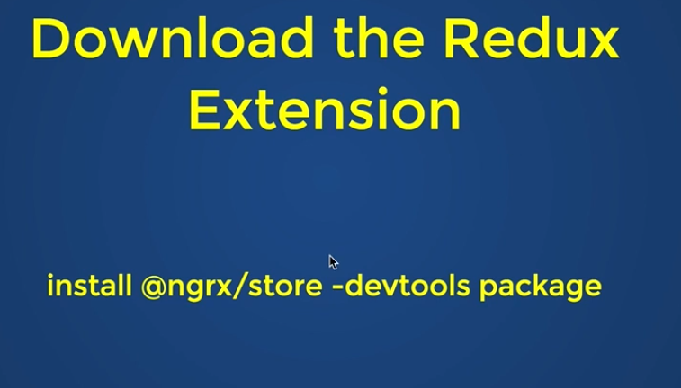

It turns green when we on redux/ngrx page

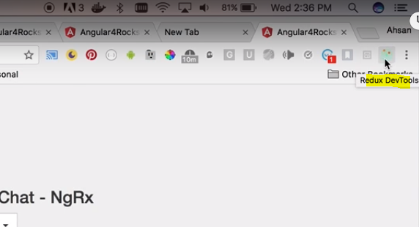

It contains all dispatched actions, which we can jump or skip

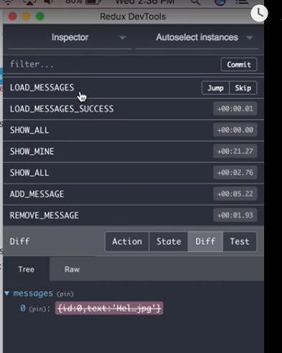

It has time travel debugger, if we find a bug and want to report, we press play button, and application will start playing

And whatever actions u dispatched, it will be recorded